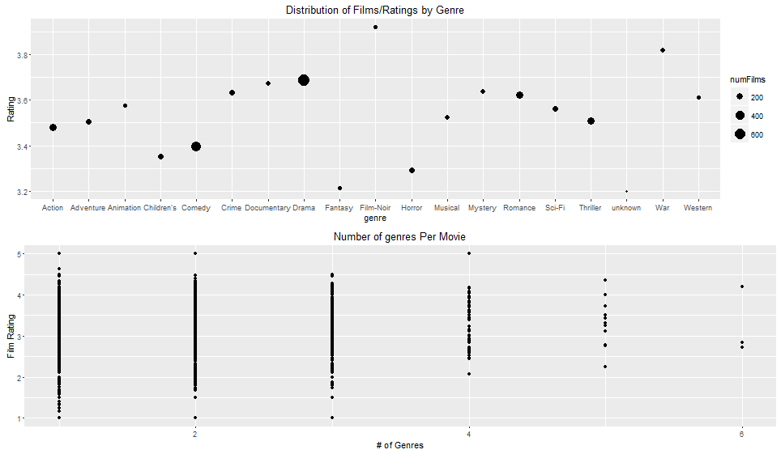
The figure above shows the average rating for each genre of film. The figure below shows the number of genres associated with each film film. The exact distribution is (833, 569, 215, 51, 11, 3) for i = 1, 2,..., 6 labels. There is about a 50% chance that a given film will have multiple genres.

In the figure above, note that comedies and dramas dominate the genre (reflected by the size of the points). Comedies are notably rated around 0.3 stars lower than dramas. Given that most of the variation in ratings by genre is primarily a result of having very few films, this sticks out as the most obvious trend--"fun" genres like action, children's, horror, and family are very low, while "serious" genres like Drama, Documentary, Crime, Mystery, Romance, and War are very high rated.

Obviously it's impossible to know the "true" rating of any movie, but without knowing the actual difference in quality between two movies, can we explain the primary force which drives this rating disparity between silly and serious? Are heavy users rating serious movies more heavily and at a higher rating? Is there a broader base of users watching comedies? Can this be explained by the little demographic information we have (age, gender, and occupation)? Finally, the large difference in ratings between comedy and drama exists in part because a small proportion of films (89/1682) are in both categories while more (1052/1682) are in one or the other. How much do genres overlap, and to what extent do they overlap (and to what extent does correlation help to influence ratings)?

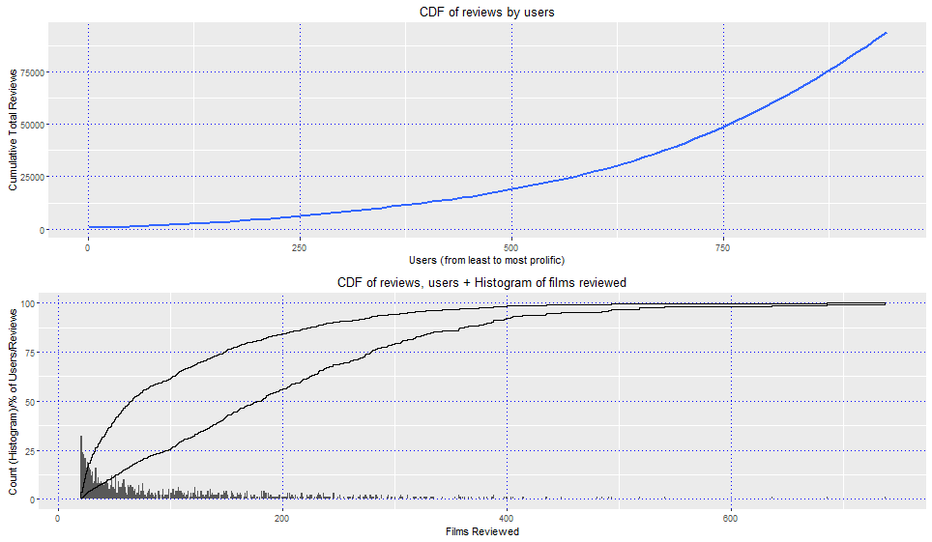
Here are some results on the distribution of ratings. As can be seen in the figure above, which shows the CDF of ratings by users, less than 250 users account for more than half the ratings, and half the users (472) account for less than a quarter of ratings.

As the diagram below shows, the median user is at around 65 ratings, but the median rating is made by a user with around 180 reviews.

